**Build and deploy the application in Apache tomcat server:**

**Step-1:**

**Here we are going to upload .war file into the Apache tomcat server, so we need to generate .war file using our code.**

1. Go to manage Jenkins

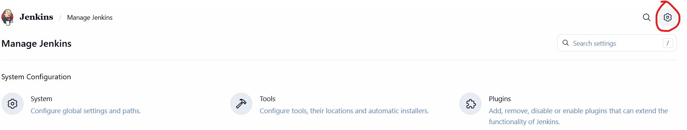

2.click on tools 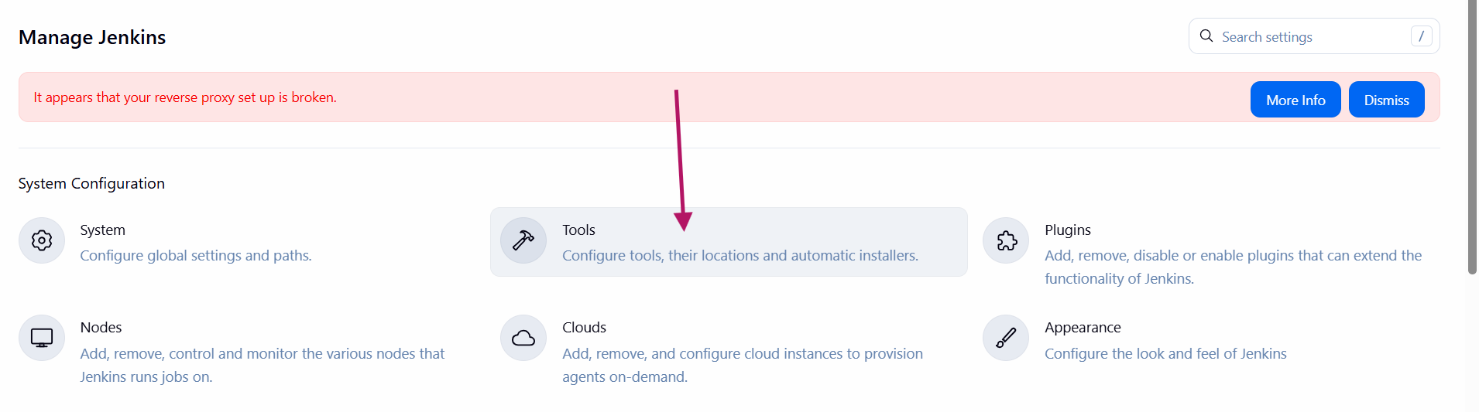

3.here I am going to add maven to build the .war using maven environment.

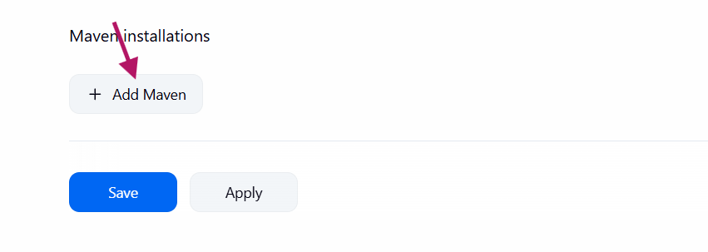

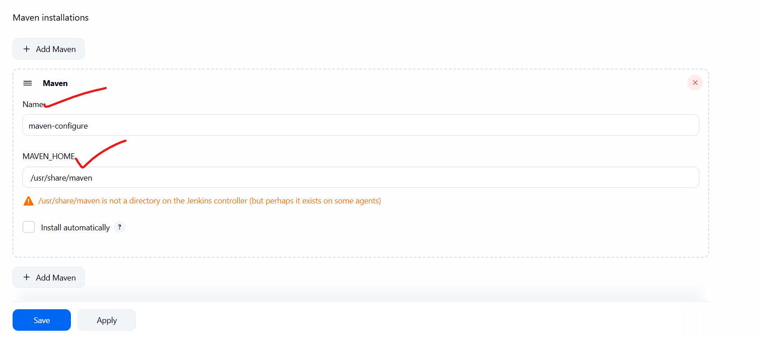

If maven not installed on Jenkins server

$ sudo yum install -y maven

$ mvn -version

Get the mvn home directory and provide in the above maven environment.

**Step-3:**

1. Create new Item and provide description.

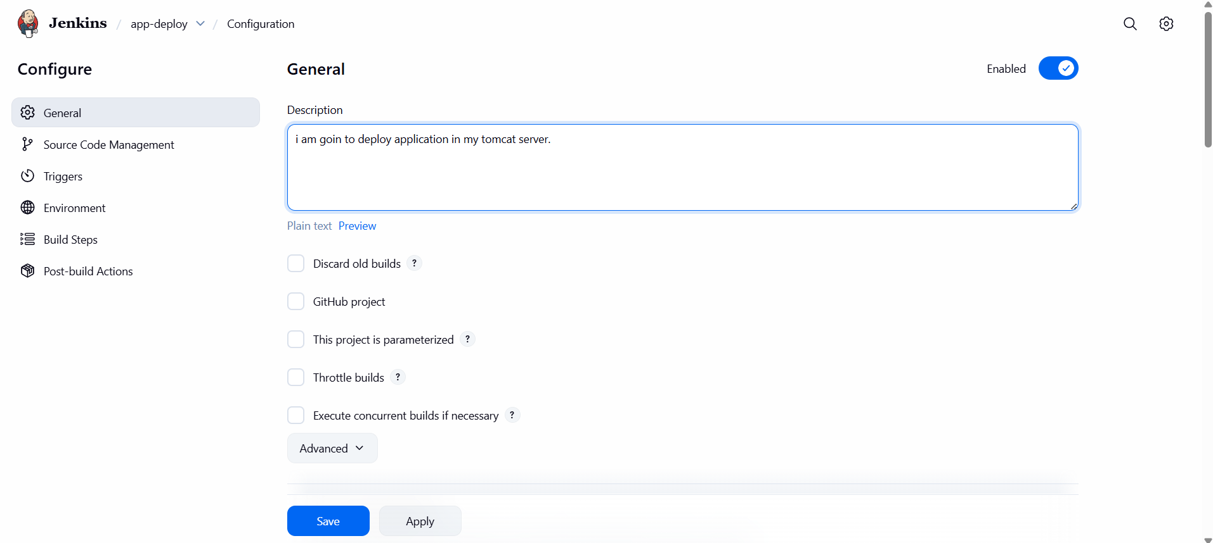

1. Goto git and provide our project url

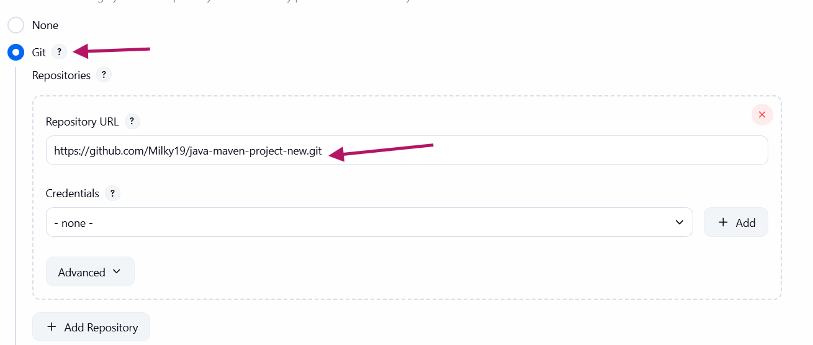

3.goto build step and select the **Invoke top-level Maven targets**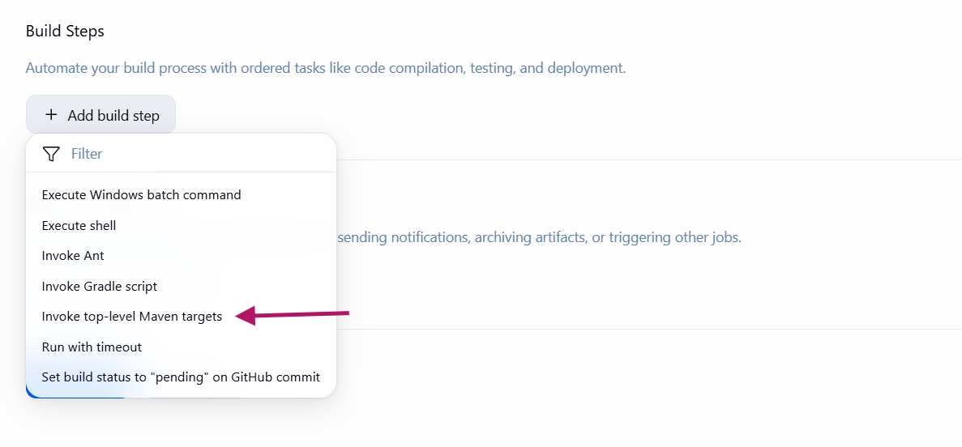

4. we can select maven version which was configured before.

And Goal is to package our project to .war file

GOALS:

**clean package** ----> it will clean the maven and package directly

or

we can do manually step by step

**compile** ---- > compile the project

**test** ----- > Run unit tests

**package** ------ > package the application.

**Note: the above steps are building phase**

**Now we are going to deploy war file into Apache tomcat.**

**Step-4:**

To deploy application into Apache Tomcat we need to install one plug-in

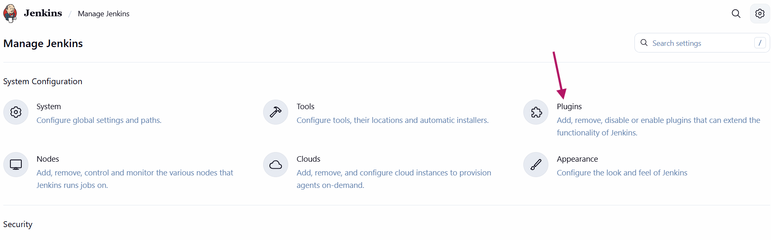

Select available plug-ins and search for the deploy to container and install it.

**Step-5:**

Goto jobs and configure the job

Goto post-build actions and click on Add build-action

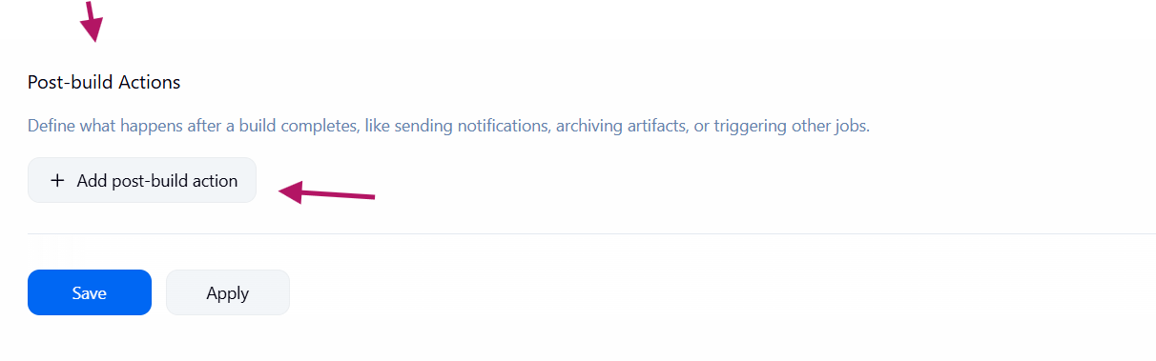

**Step-6:**

1.Select Deploy war/ear to a container

2. provide the WAR/EAR FILES as

**/*.war means [current directory / all .war files

3.provide context path anything.

4. Click on container and select the tomcat container because we are going to deploy on tomcat server.

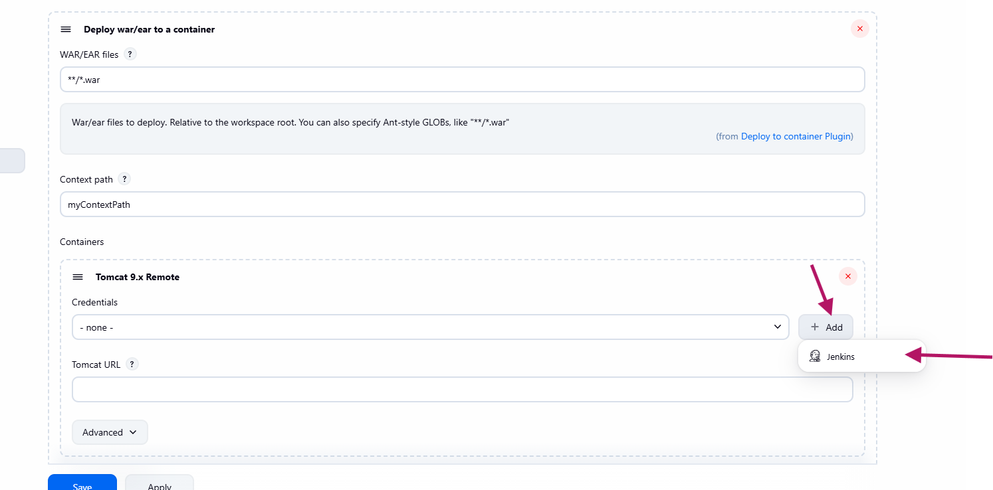

5. Provide the tomcat server details like username and password to connect remotely through the jenkins

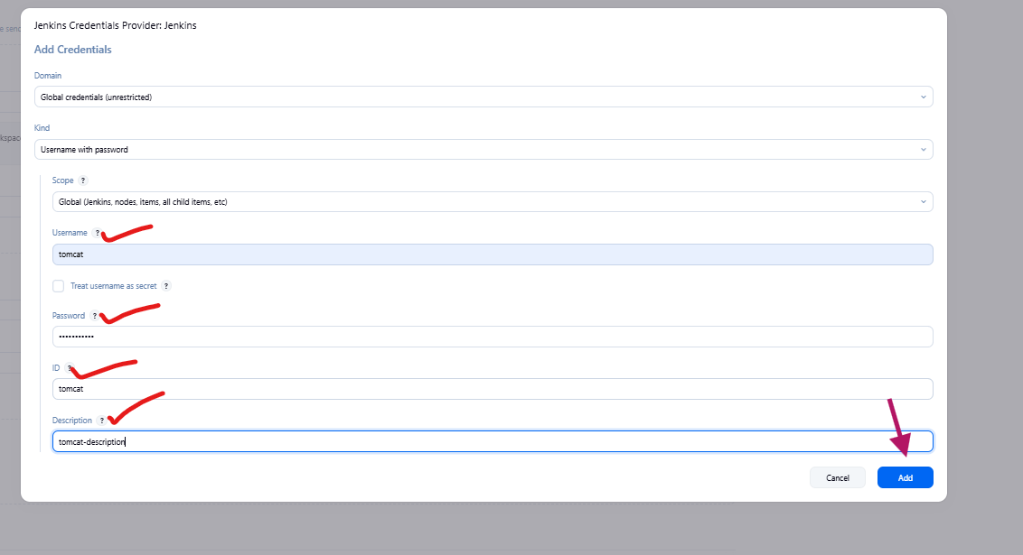

6.provide the tomcat dashboard URL and apply & save it.

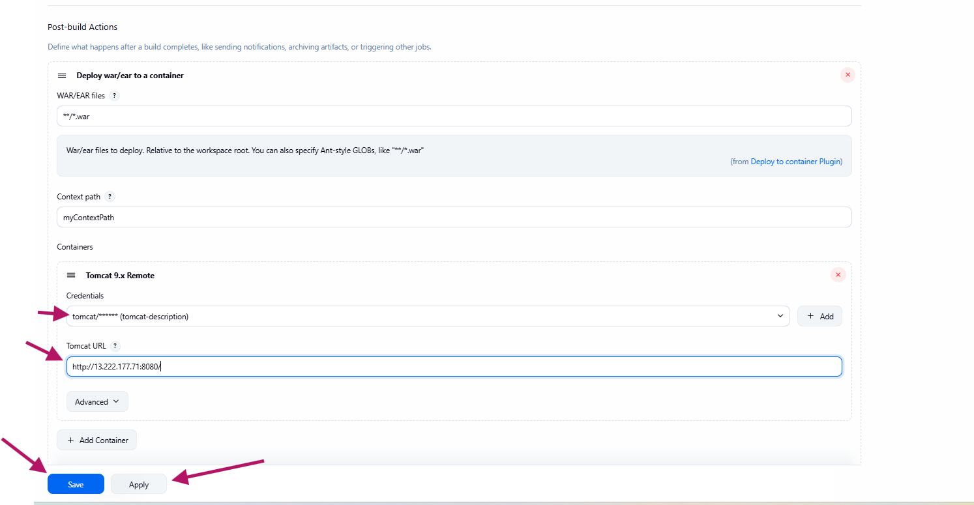

7. click on Build now

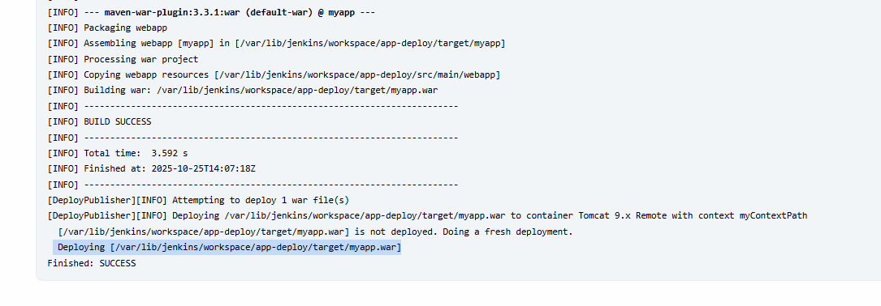

**Step-7:**

Login into tomcat server and validate deployed application

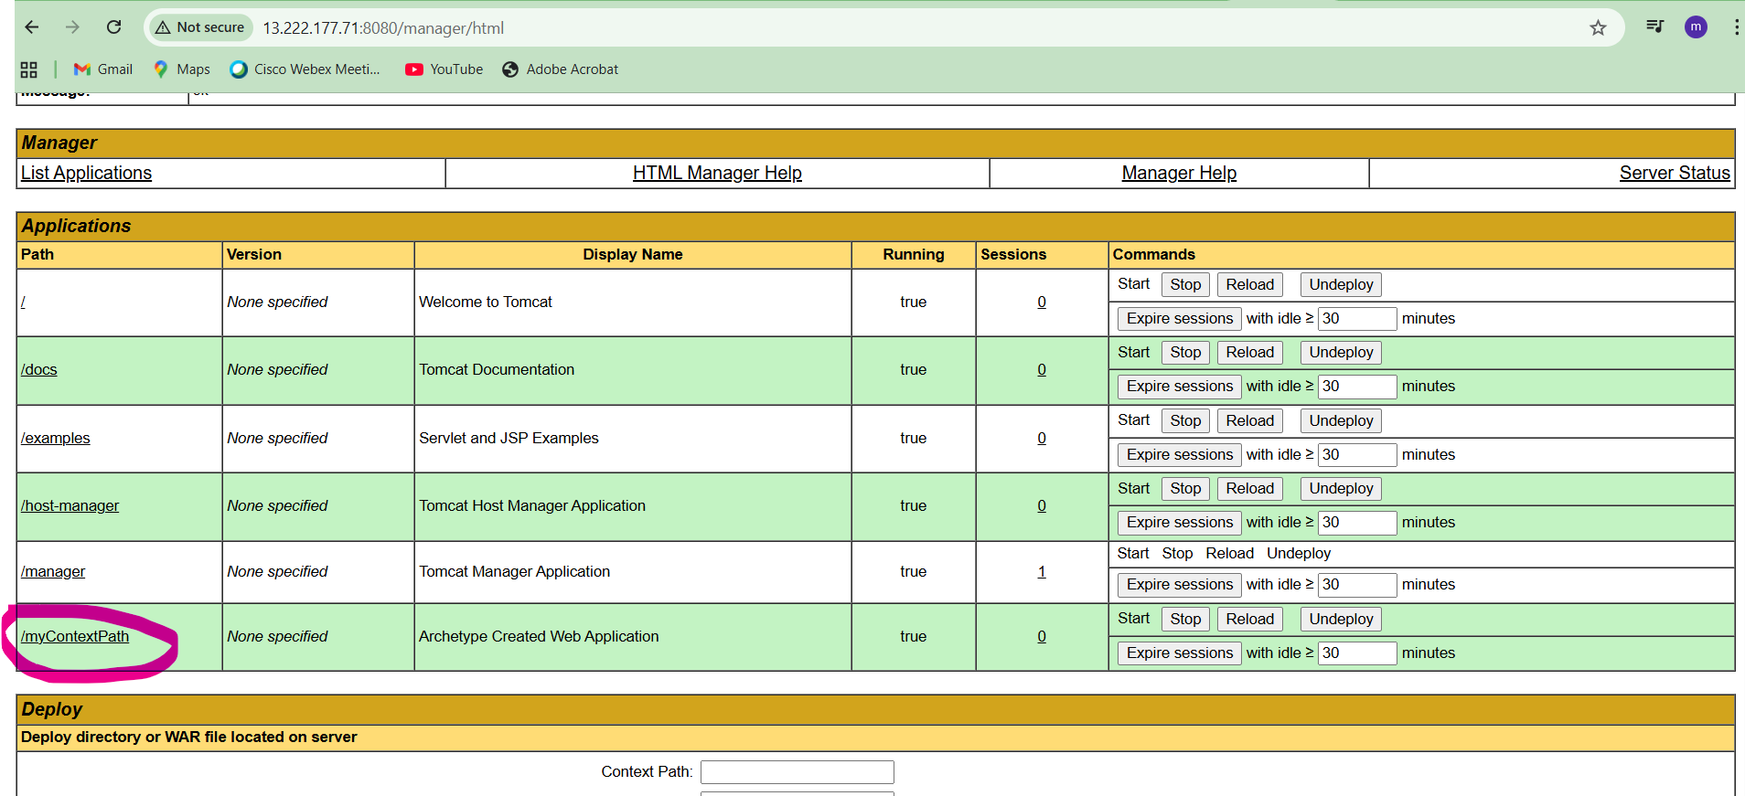



Application successfully deployed on apache tomcat server and running successfully.